### TOROS University

#### Computer and Software Engineering Department

##### SCE-216 Web Programming 2

##### Lecturer: Asst. Prof. Dr. Maryam Eskandari

**Duration: 60 minutes**

**Name, Surname . . . . . . . . . . .**

****

|  |
| --- |
| ***Q1. /*** |
| ***Q2. /*** |
| ***Q3. /*** |
| ***Q4. /*** |
| ***Q5. /*** |
| ***Q6. /*** |
|  |
| Total |

**Student ID # . . . . . . . . . .**

****

**Grading:**

Please, check your exam sheet and make sure that it contains **6 questions** .In case of **any missing pages**, **inform the invigilator** IMMEDIATELY !

****

**1) How can the index.php script access the email form element of the following HTML form?**

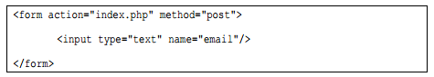

Answer:



**2)** **What will be the output of the following script?**

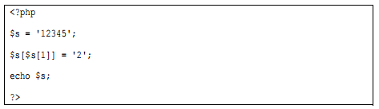

Answer:



**3)** **This question refers to a table named president with schema as follows:**

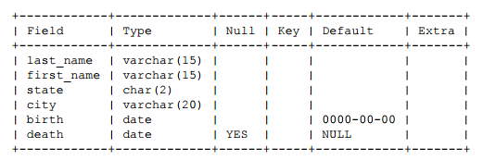

1. **Write an SQL query that returns the full names of presidents who are still alive.**

|  |
| --- |
| $query =”SELECT last_name, first_name FROM president WHERE death ! = “YES””;  while($tablename = mysqli_fetch_array($query))  { echo $tablename[' last_name '] ." ";  echo $tablename[' first_name '] ." "; } |

1. **Write an SQL query that finds the state in which the greatest number of presidents have been born.**

|  |
| --- |
| $query =”SELECT MAX(state) FROM president  while($tablename = mysqli_fetch_array($query))  {  echo $tablename[' state '] ." ";  } |

1. **Write an SQL query that finds the full name of every president between 60 and 70.**

|  |
| --- |
| $query =”SELECT last_name, first_name FROM president WHERE (2017-birth BETWEEN 60 AND 70)”;  while($tablename = mysqli_fetch_array($query))  {  echo $tablename[' last_name '] ." ";  echo $tablename[' first_name '] ." ";  } |

**4)** **Write a SQL statement to create a simple table employees including columns id, name and salary.**

|  |
| --- |
| CREATE TABLE employees(  ID int (10),  NAME varchar(40),  SALARY float(10)  ); |

**5)** **Write complete PHP code to delete all students with grades less than 50 from table student of mydatabase using a textbox and button, show your deleted items into a textarea using method POST.**

|  |
| --- |
| <html>  <body>  <form method="POST" >  <br><br>  <input type="text" name="gradeinput" value="">  <input type="submit" name="deletebygrade" value="DeleteByGrade">  <br><br><br>  <textarea rows="10" cols="60" >  <?php  if(isset($_POST["deletebygrade"])&& isset($_POST["gradeinput"]))  {  $gradeinput=$_POST['gradeinput'];  $conn = mysqli_connect('localhost', 'root', '','mydatabase') or die("not connect");  $query= mysqli_query($conn,"DELETE FROM student WHERE Grade<$gradeinput");  if ($query)  echo "The Student with grade graeter than ".$gradeinput." has beed deledted!" ;  }  ?>  </textarea>  </form>  </body>  </html> |

**6) Suppose we have the following 1D arrays, write a complete PHP code to find the sum of arrays.**

10 2 3 5 7

**Array a =**

1 0 1 1 4

**Array b=**

**sum=**

11 2 4 6 11

|  |
| --- |
| <?php  $a=array(10,2,3,5,7);  $b=array(1,0,1,1,4);  for ($i=0; $i<5; $i++)  sum[$i]=a[$i]+b[$i];  for ($i=0; $i<5; $i++)  echo sum[$i];  ?> |